**Discussion 5 - 2**

***Part 1***

*For today’s in-class demo, summarize,*

* What was the trickiest step that you encountered within the time given? Is there a step that you think took longer than it should have?
* If you had another 10 minutes to work on this, what would you try to improve?
* In the space below, include any screenshots / video recordings of your results.

***Part 2***

*Can you improve this visualization?*

library(tidyverse)

coffee <- read_csv("<https://go.wisc.edu/b34tma>")

coffee_counts <- count(coffee, `What is your age?`, `How many cups of coffee do you typically drink per day?`)

ggplot(coffee_counts) +

geom_col(aes(

`What is your age?`,

n,

fill = `How many cups of coffee do you typically drink per day?`

)

)

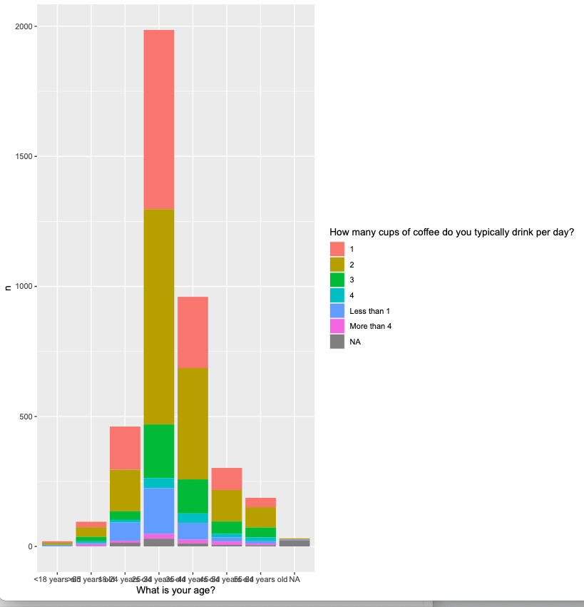

**Responses**